Innovation Evaluation Report

About the Project :

Cycle-ops is a team based at Sir MVIT college dedicated in making Human Powered Vehicle (HPV). Human Powered Vehicle are the vehicles that are driven by muscular strength. The HPV we aim at building is a land HPV that is built for competitions. We aim at making the vehicle faster, efficient and comfortable for the rider.
The team also has an Innovation Department that has people dedicated to make the HPV better using innovation technology.

Project Goals :

The Innovation Dept. plans to provide the rider with the information about HPV such as
-The axis information of the HPV
-The velocity of the HPV
-RPM of the HPV wheels
-Angle of the HPV
The department also focuses on automizing the gear system.

Implementation :

We will use the following sensors to get the data about the HPV (Human Powered Vehicle)

1. MPU6050 Module-

MPU6050 sensor module is complete 6-axis Motion Tracking Device. It combines 3-axis Gyroscope, 3-axis Accelerometer and Digital Motion

Processor all in small package. Also, it has additional feature of on-chip
Temperature sensor. It has I2C bus interface to communicate with the
microcontrollers. So this module will be used to get the axis information and also to measure the velocity of the HPV.
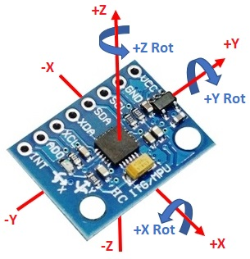

MPU6050 sensor has many functions over the single chip. It consists a MEMS accelerometer, a MEMS gyro, and temperature sensor. This module is very accurate while converting analog values to digital because it has a 16bit analog to digital converter hardware for each channel. This module is capable to capture x, y and z channel at the same time.
It has an I2C interface to communicate with the host controller. This MPU6050 module is a compact chip having both accelerometer and gyro. This is a very useful device for many applications like drones, robots, motion sensors. It is also called Gyroscope or Triple axis accelerometer.

2. Hall Sensor -

A Hall effect sensor is a device that is used to measure the magnitude of a magnetic field. Its output voltage is directly proportional to the magnetic field strength through it. Hall effect sensors are used for proximity sensing, positioning, speed detection, and current sensing applications. So this sensor will be used to measure the RPM of the HPV Wheels.
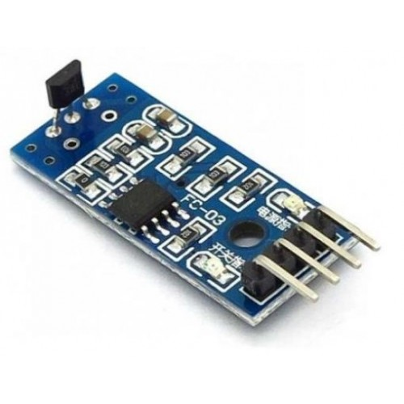

We will use this sensor to measure the pedalling rate (or cadence) for the Human Powered Vehicle (HPV)

Arduino is the microcontroller we will be using to communicate with the sensors.
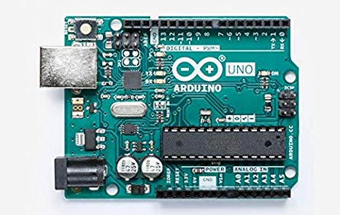

We are also using NodeMCU which is an open source IoT platform. It includes firmware which runs on the ESP8266 Wi-Fi SoC from Espressif Systems, and hardware which is based on the ESP-12 module. It will be used to upload the sensor data we obtain to the IoT servers which will be accessible to the team for the performance review.

Subsystems in Human Powered Vehicle (HPV) :

- System that automatically changes the gear for the maximum efficiency
of the Human Powered Vehicle (HPV).
The gear shift will depend on the angle, velocity and also upon the rider’s
comfort. For maximum efficiency the as per the velocity and the angle of
HPV, the gear will be automatically adjusted.
So clearly the velocity and angle of the HPV are the inputs to the system.

- System that calculates the pedalling rate (or cadence). In cycling, cadence
is the number of revolutions of the crank per minute. This is the rate at
which a cyclist is pedalling / turning the pedals. Cadence is directly
proportional to the wheel speed, but is a distinct measurement and
changes with gearing – which determines the ratio of crank rpm to wheel
rpm.
Hall effect sensors will be used as proximity sensor to calculate the
pedalling rate (or cadence).
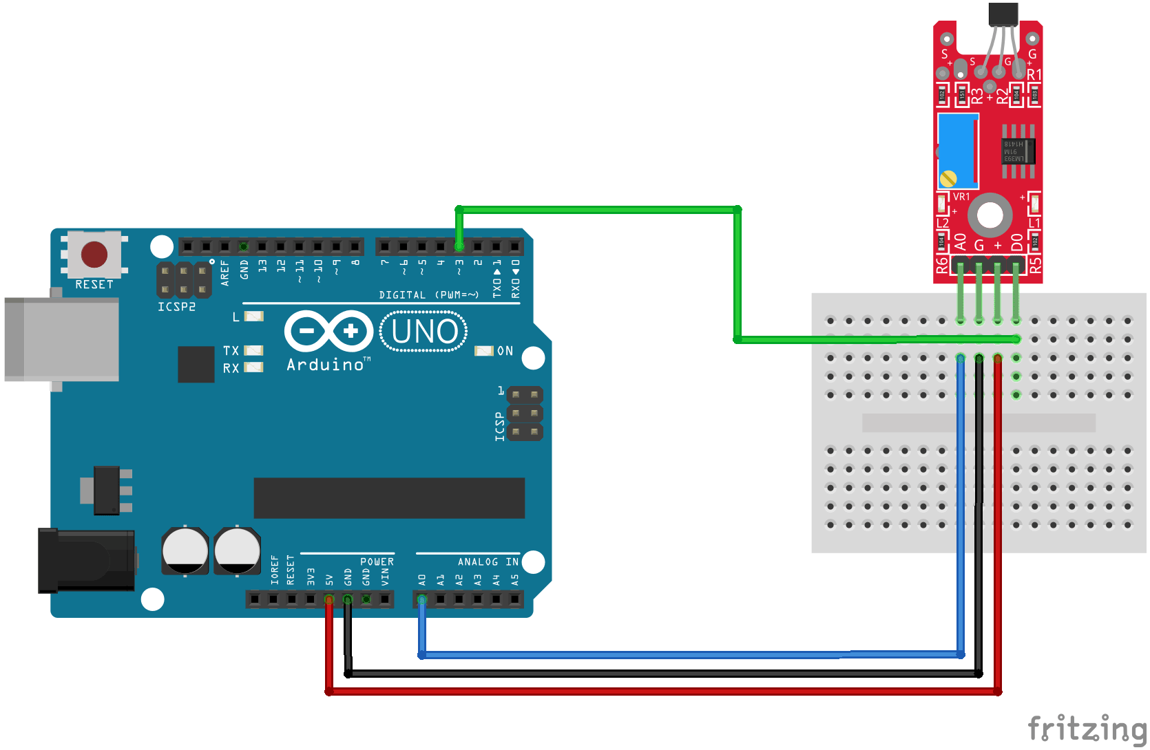

- System that calculates the Velocity of the Human Powered Vehicle
(HPV). We want the velocity to be calculated in all the three axes.
So for that we will use MPU6050 Module sensor. Particularly we will
use the 3-axis Accelerometer and Digital Motion Processor of the
MPU6050 Module. The output of this system will be fed as input to the
Gear Automation System mentioned above.

- System that calculates the angle at which the Human Powered Vehicle is
moving. For this calculation we will use MPU6050 Module Sensor.
Particularly we will use 3-axis Gyroscope of the MPU6050 Module
Sensor. The output of this system will be fed as input to the Gear
Automation System mentioned above.
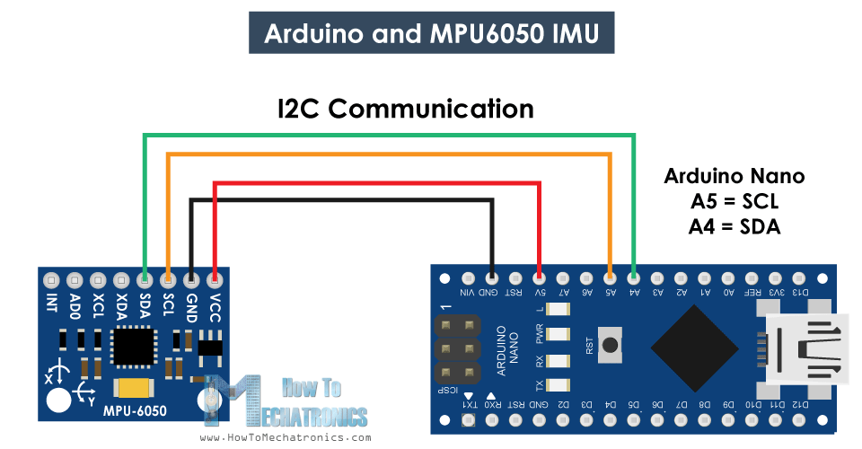

- System that automatically balances the Human Powered Vehicle at very
low speeds. The output of the System the calculates the Velocity will be
fed as an input to this system. When the velocity reaches a level at which
the balance is disturbed it will trigger the system and a pair of additional
two small wheels will be rolled down to provide balance to the HPV.

In all of the above Systems we will use the Arduino Microcontroller to communicate with the sensors to perform the required task.
The out of the above systems is the data we want to upload to the IoT servers. To serve this purpose we will use NodeMCU which is an open source IoT platform.
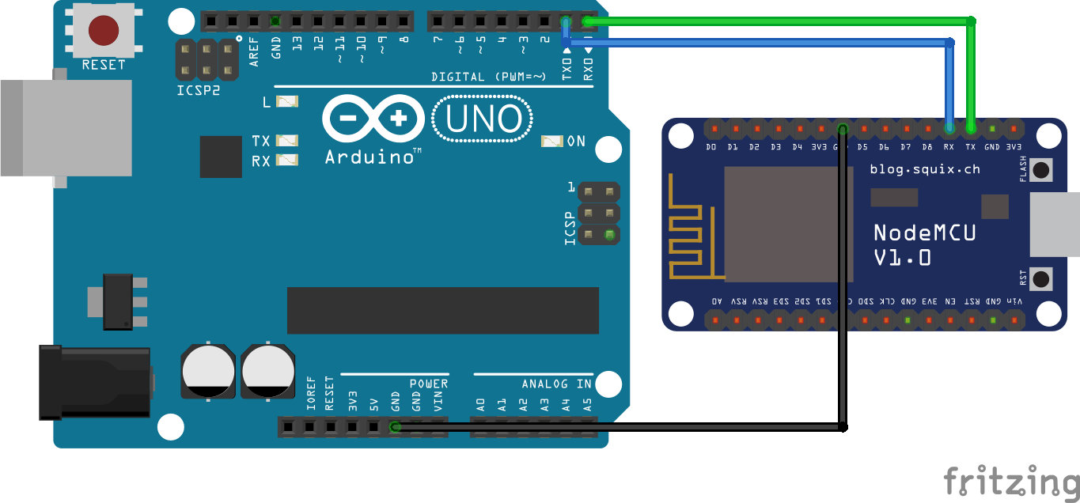
NodeMCU is an open source LUA based firmware developed for ESP8266 wifi chip. By exploring functionality with ESP8266 chip, NodeMCU firmware comes with ESP8266 Development board/kit i.e. NodeMCU Development board.
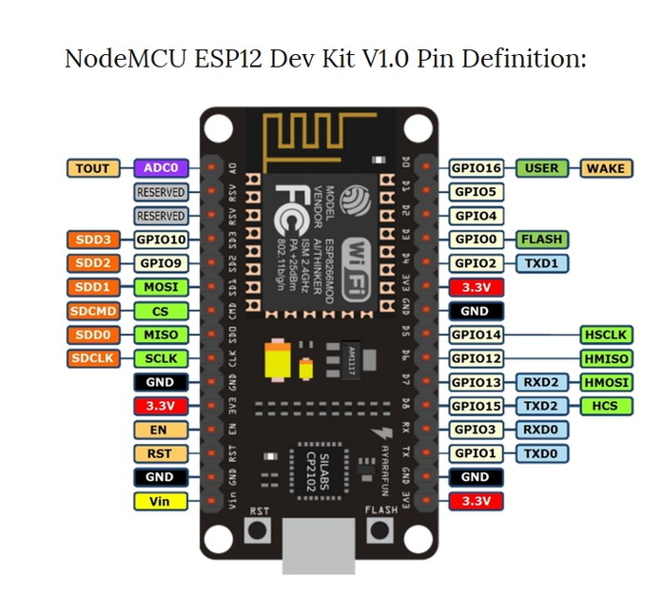

Since NodeMCU is open source platform, their hardware design is open for edit/modify/build. NodeMCU Dev Kit/board consist of ESP8266 wifi enabled chip. The ESP8266 is a low-cost Wi-Fi chip developed by Espressif Systems with TCP/IP protocol.
The data uploaded to the IoT servers will be used for the performance review by the analysts.

OutComes :

We trust our team to complete the above mentioned Innovation objectives in time. The Innovation will help the rider analyse the HPV better and ride more efficiently.

